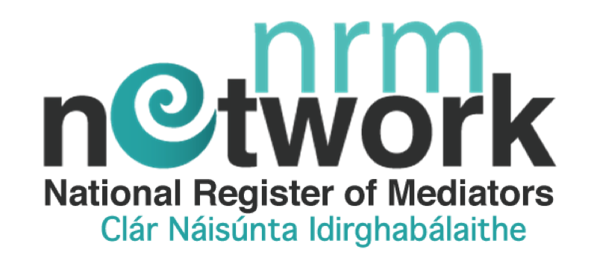

QUALIFIED / CERTIFIED /ADVOCATE
MEMBERSHIP & ONLINE PROFILE APPLICATION

Your General Details
Please indicate membership type | Qualified ______ or Certified _______  or advocate ________
Email Address
Title
First Name
Last Name
Address (Non-Public Profile)
Line 1
Line 2
Town
County
Country
Address (Public Profile Version)
County
Country
Website
Mobile
Office Landline

Mediation Practice Details & Professional Background

1.
2.
3.
4.
5.
Please include a copy of certificates of accreditation and and evidence to support 100 hours of mediation practice i.e actual practice and/or role plays if you are applying for Certified Membership.
Please Note: The NRM may request video evidence of your assessment role-play as part our our annual audit process.
PENDING APPROVAL
(Please do not send originals as they will not be returned to you).

- Copy of qualifying QQI certificate from NRM Network approved CMTP
- Supporting documentation/evidence of 20 mediations or 100 hours of mediation practice i.e. actual practice and/or role play practice* - Role plays must be from previous 12 months

Process of application for equivalence of training done with a body other than an approved CMTP

If you have completed training other than an NRM approved training programme and believe that you have equivalent skills, you can apply for membership based on Equivalence of Training.
You must be able to comply with the following requirements to make an application:
- Completion of a minimum 40-hour training course in mediation skills and practice
- Successful recorded role-play skills assessment (NRM may request a demonstration role-play exercise(s) before approving application
- Supply certified evidence of your training and assessment
- Supply course curriculum of the training completed so that it can be assessed in comparison to the NRM Network criteria requirements

NOTE: The NRM Network will accept qualified and certified membership of the International Mediation Institute (IMI, ‘The Hague, Netherlands) without the need to supply a videoed role play.

Please complete and include the ‘Application for Recognition of Training Form’ in addition to this application
Applicants who are successful will be granted Membership.
Which geographic locations do you work in?

Bio of your mediation and professional background

Main Mediation Practice Areas
eg. workplace, community, family, elder etc. 1.
2.
3.
Other
Description of Mediation Style
Eg facilitative, transformative etc

Code of Conduct Subscribed to 1. | NRM Network Professional Code of Conduct
2. | Other, please state
Complaints process subject to 1. | NRM Network Complaints Policy
2. | Other, please state
Professional Indemnity Insurance | All certified members are required to have professional indemnity insurance before commence professional practice
Education & Training
Details of your formal mediation education

Other relevant training & education

References
Reference 1
Name
Profession
Contact Number
Email
Reference 2
Name
Profession
Contact Number
Email

Please make sure you have fully completed this form, also that you have enclosed copies of all backup documentation. Should required details or documents be
missing it will delay your application being processed
.
BANK DETAILS

Payment of Membership Contribution made payable to
NRM Network CO. LTD t/a National Register of Mediators

via bank transfer or online banking
(NB: Please ensure to use your name as a reference and please wait until your membership is approved)

IBAN: IE85 BOFI 9040 3480 0632 03 BIC: BOFI IE 2D

Fee Contribution Structure
Certified Membership/Qualified Membership | 125.00 euro
Membership / Profile listing for a 12 month period from date of issue

Please advise if you have paid a Trainee contribution prior to this application

Yes _____ or No _____

I wish to apply for the following category of membership
(tick one box only)

NRM Qualified Membership (Just qualified with an NRM approved Certified Training Programme and and limited practical experience) ☐

NRM Certified Membership (Fully Qualified as above and can provide evidence of 20 mediations or 100 hours of mediation practise and/or role plays practice ☐

If you wish to register on our Volunteer Panel (this is a panel that will be made available to community mediation schemes for voluntary service in the future)

I wish to register on the NRM Network Volunteer Panel ☐ ______________________________________________________________
Please state the region(s) you are available for
______________________________________________________________

PROFILE PHOTO (required for Certified Membership only)

Please also include a profile photo along with your application. The photo should reflect a professional image and be 500 pixels in height & 375 pixels in width.

Code of Conduct & Complaint Process & Privacy Declaration
- I have read the NRM Network’s Criteria to become a member policy and I confirm that I meet this criteria.
- I have read and agree to be governed by the NRM Network code of professional conduct.
- I have read and agree to be governed by the NRM Network's complaint and appeals process.
- I have read and understand the NRM’s privacy policy and consent to the processing of my personal data as described.
- I understand and I give permission for the NRM Network to request to see my final assessment video role-play from my CMTP Provider when applying for membership.
- I agree that the NRM Network may contact me though the contact information provided.

Signed: ________________________________ Date: ____________

(We also accept an electronic signature)

Have you checked your document and provide all necessary attachments, including a photograph (for Certified Membership only). Remember incomplete application forms cannot be reviewed or approved.

NRM Network CLG is a non-profit registered charity in Ireland. Registered in Dublin, Ireland.
Charity Registration No. 20205432. Company Registration No. 565601

